

**DIGITAL ASSIGNMENT 4**

**NAME: AYUSH SHARMA**

**REGISTER NUMBER: 21BDS0058**

**COURSE CODE: BCSE302P**

**COURSE NAME: DATABASE SYSTEM LAB**

**Write a PL/SQL procedure to accept an employee name and display his Department names.**

# SQL Command:

create procedure dispDepName(F_Name in Employee.First_Name%type) as

Dep_Name Department.Department_Name%type; Dep_number Department.Department_Number%type;

begin

select Department_Number into Dep_number from Employee where First_Name = F_Name; select Department_Name into Dep_name from Department where Department_Number = Dep_number; dbms_output.put_line('Department Name of '|| F_Name || ' is ' || Dep_Name);

end;

/

Execute dispDepName('Doug');

Page 1 of 19

# Screenshot:

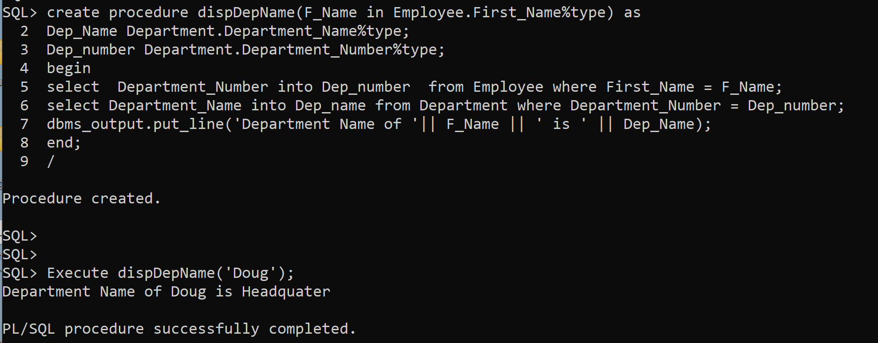

**Write a PL/SQL procedure to accept department number and display the employee whose salary is greater than the average salary of that department.**

# SQL Command:

create procedure salAvg(Dep_Num in Department.Department_Number%type ,F_Name out Employee.First_Name%type) as v_avg_sal number(7,2);

begin

select avg(Salary) into v_avg_sal from Employee where Department_Number = dep_num; select First_Name into F_Name from Employee where Salary >= v_avg_sal and Department_Number = dep_num;

end;

/

declare

F_Name Employee.First_Name%type; begin

salAvg(2, F_Name ); dbms_output.put_line(F_Name); end;

/

# Screenshot:

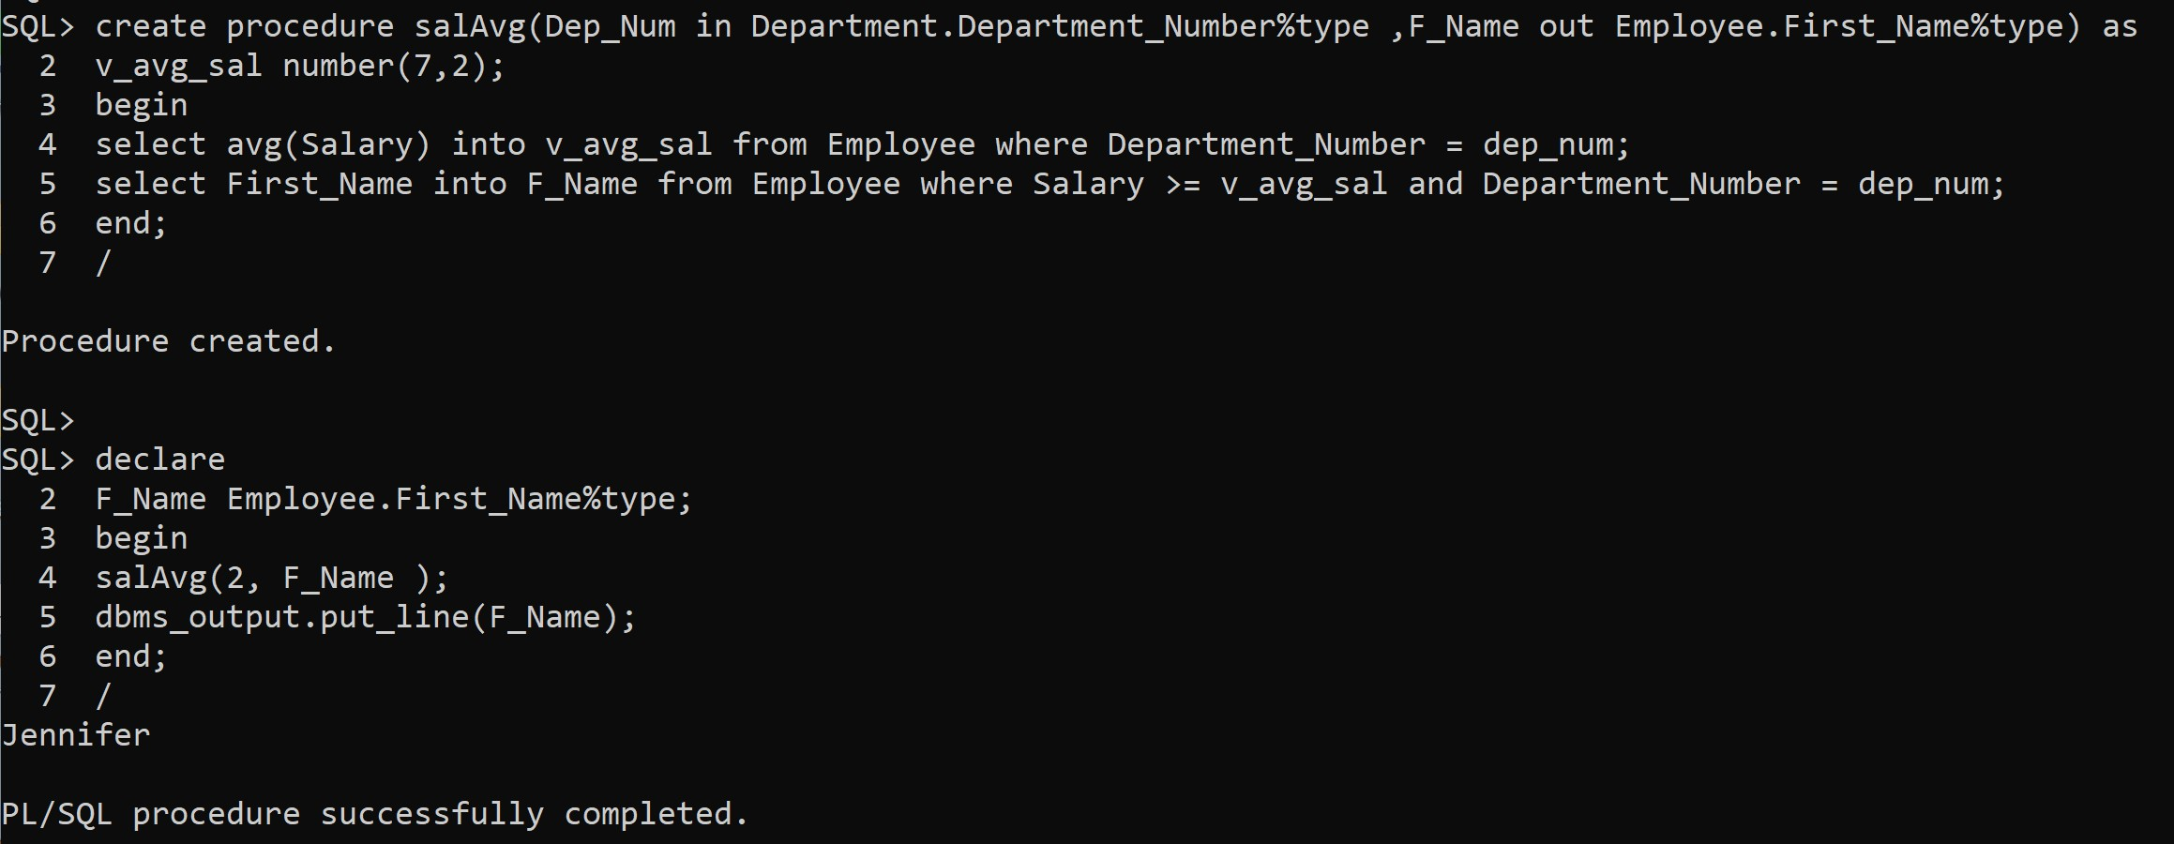

**Write a PL/SQL function to find the number of employees for a given Department name.**

# SQL Command:

create function numEmpFunc(Dep_num number) return number is

num_emp number; begin

select count(*) into num_emp from Employee where Department_Number = Dep_num;

return num_emp; end;

declare

num_emp number; begin

num_emp := numEmpFunc(1); dbms_output.put_line('The number of employees are: ' || num_emp);

end;

/

# Screenshot:

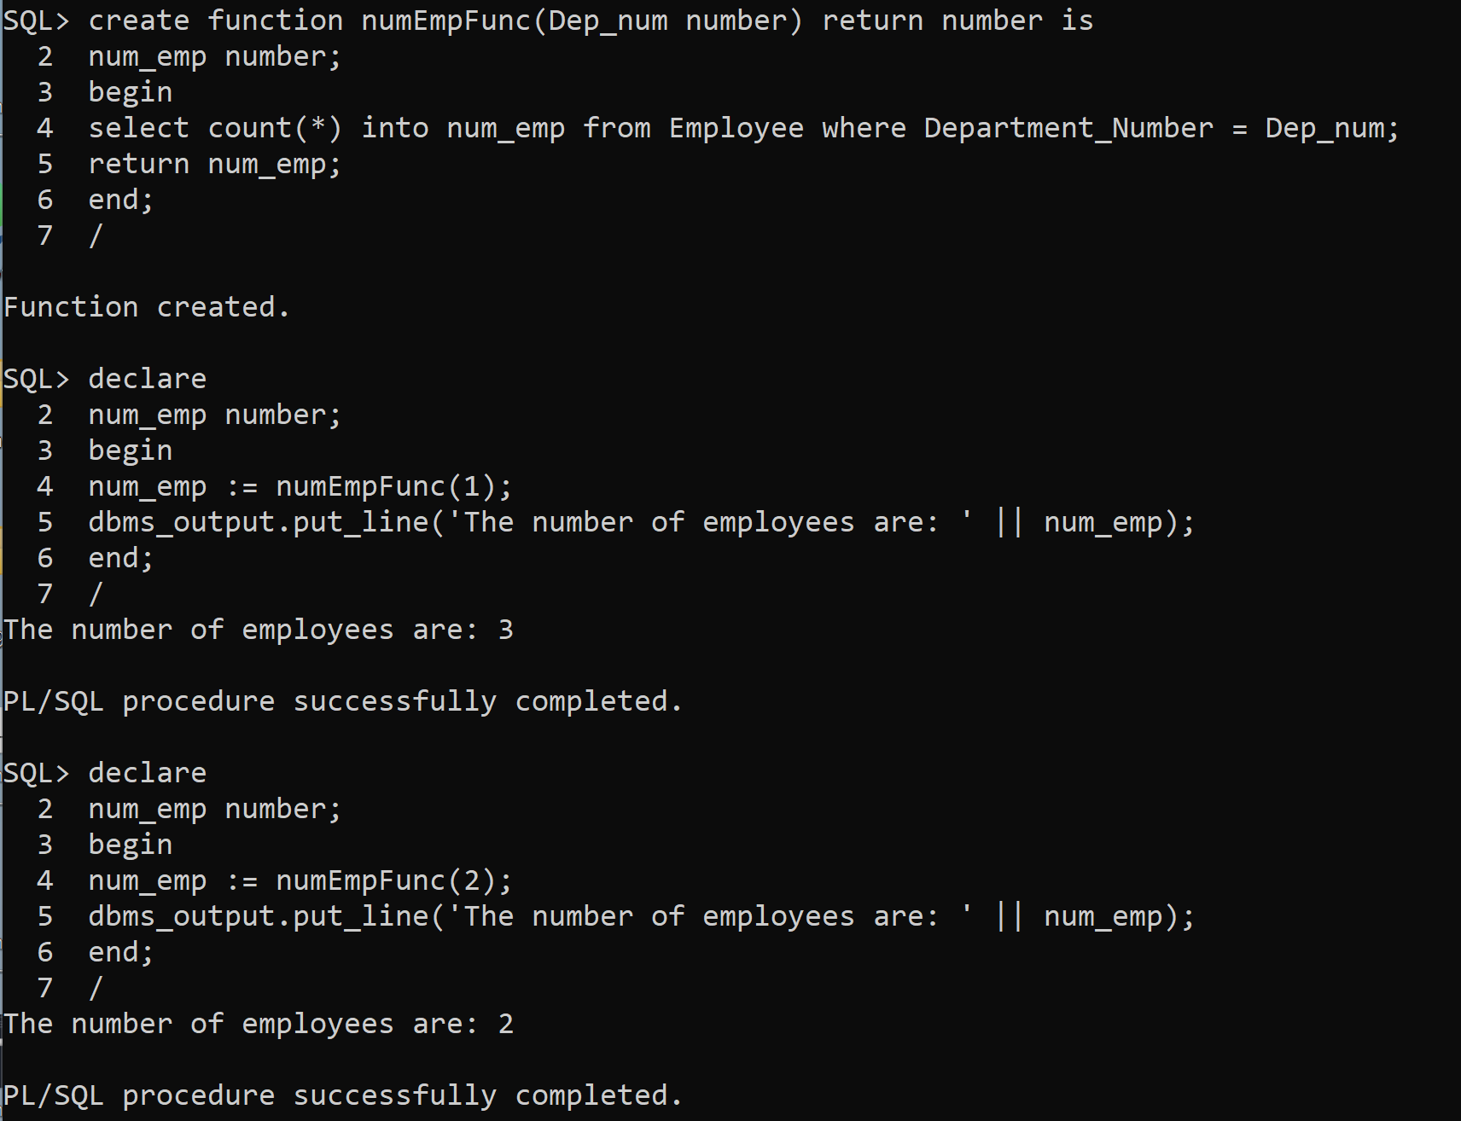

**Write a PL/SQL function to find the factorial of the given number using function.**

# SQL Command:

create function factorialFunc(num number) return number is

fact number:=1; itr number := 1; begin

while itr<=num loop

fact := fact*itr; itr := itr+1;

end loop; return fact; end;

/

declare

num number; ans number; begin

num := &num;

ans := factorialFunc(num); dbms_output.put_line('Factorial is: ' || ans);

end;

/

# Screenshot:

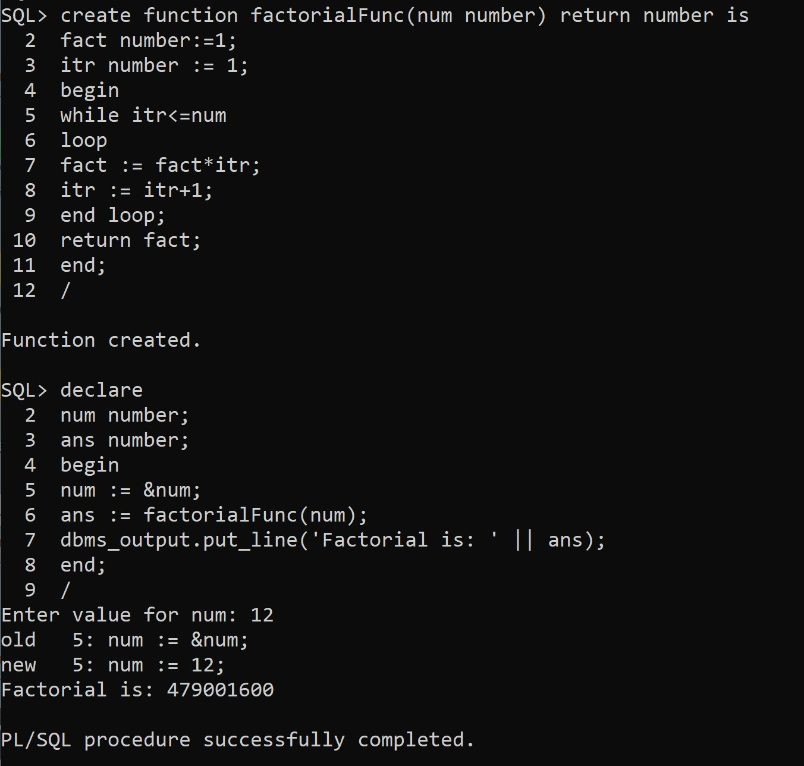

**Write a PL/SQL function to find the Fibonacci series for the given limit.**

# SQL Command:

create function fiboFunc(num number) return number is

|  |  |  |  |
| --- | --- | --- | --- |
| num1 | number | := | 1; |
| num2 | number | := | 1; |
| num3 | number | := | 1; |

itr number := 3; begin

if num = 1 then return 1;

end if;

if num = 2 then return 1;

end if;

while itr<=num loop

|  |  |  |  |
| --- | --- | --- | --- |
| num3 | := | num1 + | num2; |
| num1  num2 | :=  := | num2;  num3; |  |

itr := itr+1; end loop; return num2; end;

/

declare

nums number; ans number; begin

nums := &nums;

ans := fiboFunc(nums); dbms_output.put_line(nums || 'th Fibonacci Number is: ' || ans);

end;

/

# Screenshot:

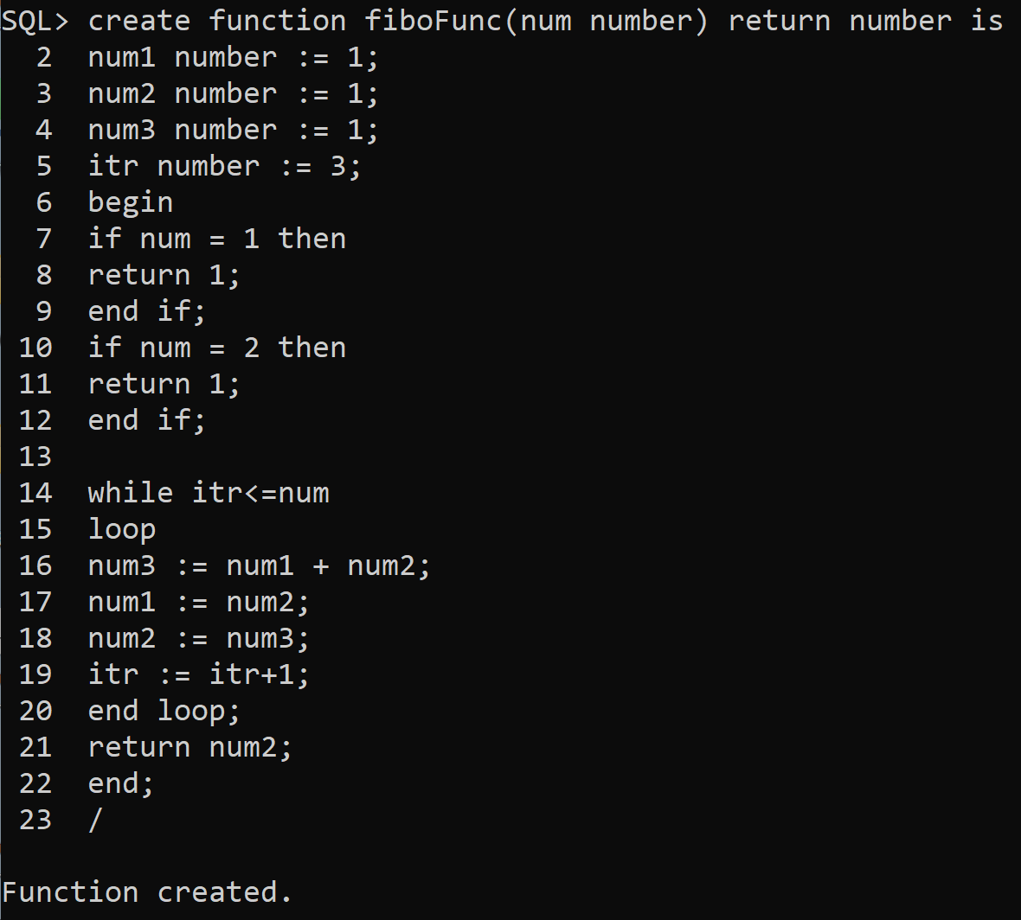

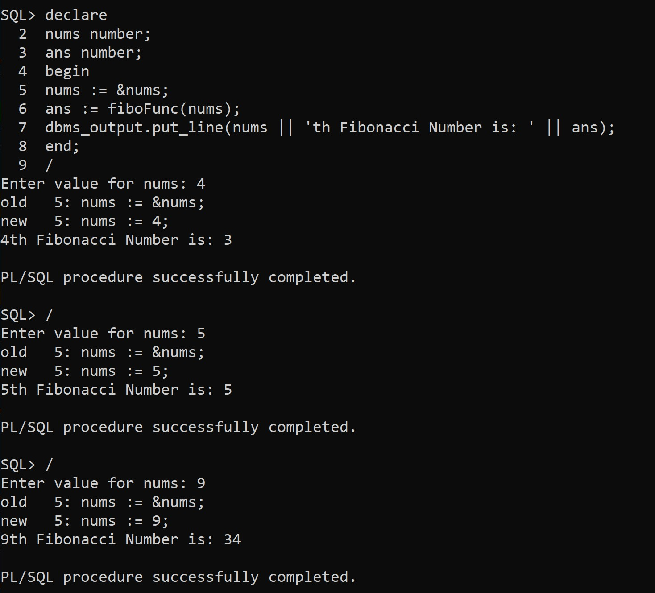

**Write a PL/SQL program to retrieve all the rows from the employee table using cursors.**

# SQL Command:

declare

cursor emp_cursor is select * from Employee; emp_record emp_cursor%rowtype;

begin

open emp_cursor; for i in 1..1000 loop

fetch emp_cursor into emp_record; exit when emp_cursor%notfound;

dbms_output.put_line('The First name is ' || emp_record.First_Name || ', SSN is: ' || emp_record.SSN_Number

|| ',The Address is ' || emp_record.Address

|| ',The Birthday is ' || emp_record.Birthday || ',The Department is '

|| emp_record.Department_Number); end loop;

close emp_cursor; end;

/

# Screenshot:

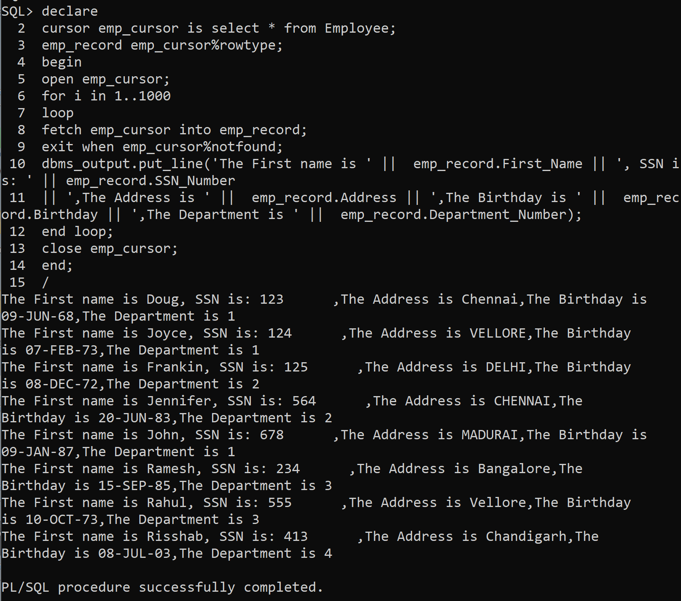

**Write a PL/SQL program to display the details of employee who is getting highest salary department headquarters using cursor.**

# SQL Command:

declare

cursor emp_cursor is select * from Employee; emp_record emp_cursor%rowtype; emp_HighestSalary emp_cursor%rowtype;

begin

open emp_cursor; emp_HighestSalary.Salary := 0; for i in 1..1000

loop

fetch emp_cursor into emp_record; exit when emp_cursor%notfound;

if emp_record.Department_Number = 1 then if emp_HighestSalary.Salary <

emp_record.Salary then emp_HighestSalary := emp_record;

end if; end if; end loop;

dbms_output.put_line('First Name is: ' || emp_HighestSalary.First_Name );

end;

/

# Screenshot:

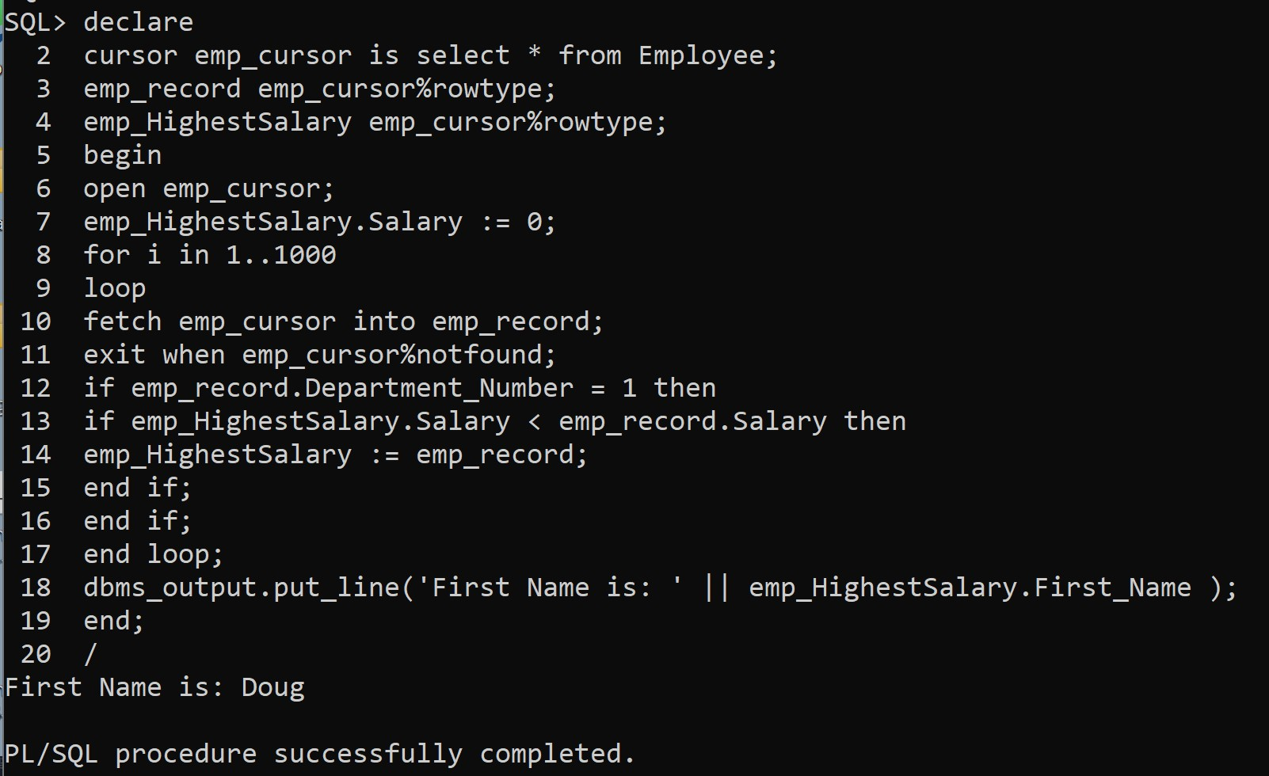

**Write a PL/SQL cursor program to display few records using joins SQL Command:**

# declare

cursor emp_cursor(E_SSN number) is select * from Employee natural join Department where SSN_Number = E_SSN;

emp_record emp_cursor%rowtype; begin

open emp_cursor(125);

fetch emp_cursor into emp_record;

|  |  |  |
| --- | --- | --- |
| dbms_output.put_line('Name is: ' || |  | |
| emp_record.First_Name || ' Department  || emp_record.Department_Name); close emp_cursor; | is: | ' |
| open emp_cursor(123);  fetch emp_cursor into emp_record; |  |  |
| dbms_output.put_line('Name is: ' ||  emp_record.First_Name || ' Department | is: | ' |
| || emp_record.Department_Name); |  | |
| close emp_cursor;  end; |
| / |
| **Screenshot:** |

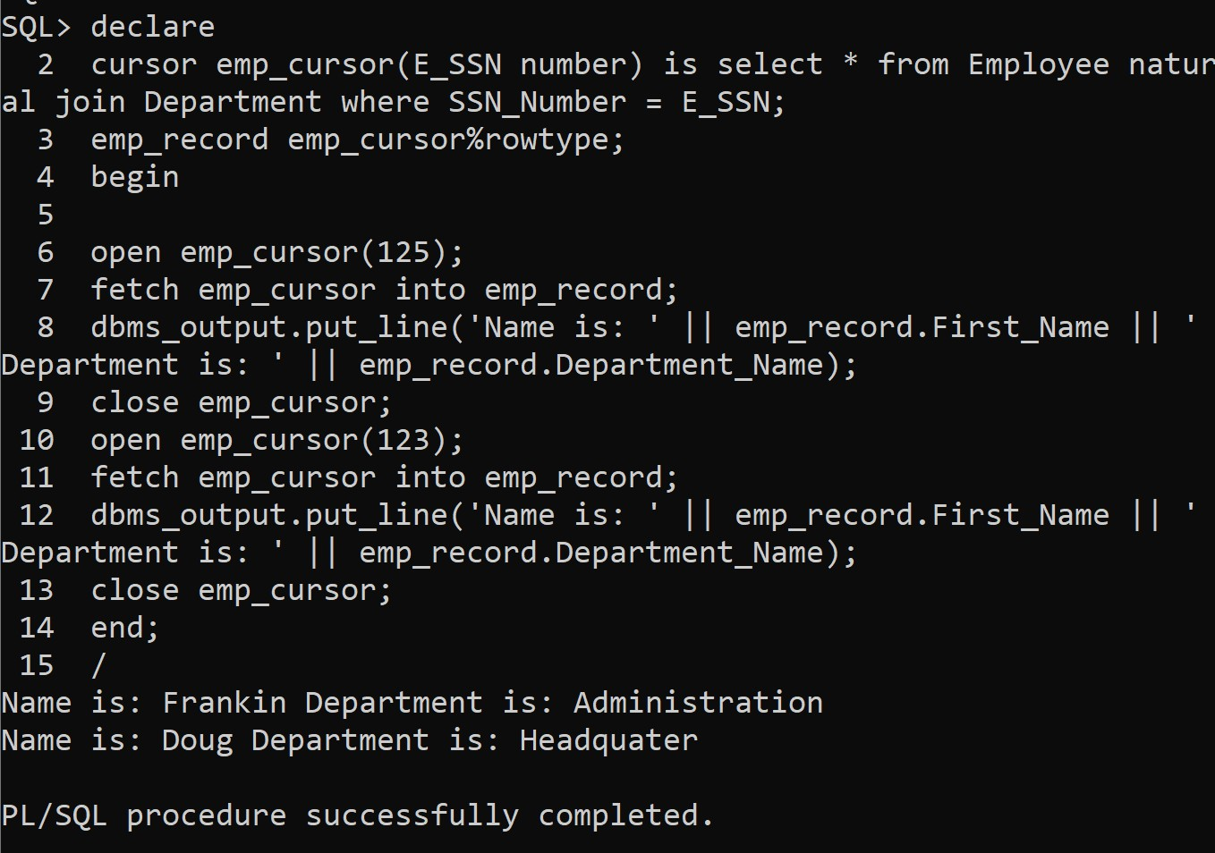

# Write a PL/SQL trigger program

**To display a welcome message “WELCOME TO THE ABC COMPANY” when a new employee record is inserted into the employee table.**

# SQL Command:

create trigger new_record after insert on Employee

begin

dbms_output.put_line('Welcome to the ABC Company');

end;

/

insert into Employee values('Steve','P','Jobs','955','24-FEB-

1955','California','M','100000','123', '2');

insert into Employee values('Elon','R','Musk','971','28-JUN-

1971','Pretoria','M','100000','123', '2');

# Screenshot:

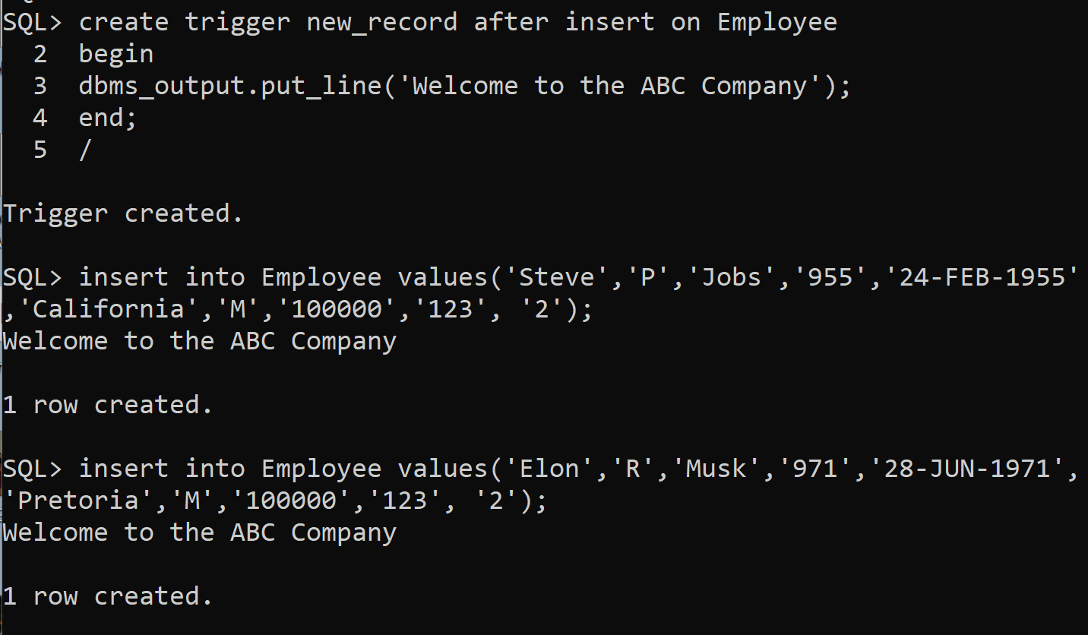

**To display “Thank you for your service” message when the employee record is deleted from the employee table and insert a record into the new table named Old_Emp(fname, mname,lname, bdate, address)**

# SQL Command:

create table Old_Emp(First_Name Varchar(15),Mid_Name Char(2),Last_Name Varchar(15), Birthday Date, Address varchar(15));

create trigger delete_record before delete on Employee

for each row declare begin

insert into Old_Emp values( :old.First_Name,

:old.Mid_Name, :old.Last_Name,

:old.Birthday, :old.Address); dbms_output.put_line('Thank you for your service');

end;

/

delete from Employee where First_Name = 'Elon';

delete from Employee where First_Name = 'Steve';

# Screenshot:

